The Title Goes Here with Each Initial Letter Capitalized
(Use the Microsoft Word template style: Paper Title)
Author’s Name^{1, a)} and Author’s Name^{2, 3, b)}
(Use the Microsoft Word template style: Paper Author)
¹(Use the Microsoft Word template style: Author Affiliation) Replace this text with an author’s affiliation
(use complete addresses). Note the use of superscript “a)” to indicate the author’s e-mail address below.
Use b), c), etc. to indicate e-mail addresses for more than 1 author.
²Additional affiliations should be indicated by
superscript numbers 2, 3, etc. as shown above.
³You would list an author’s second affiliation here.
^{a)}Corresponding author: your@emailaddress.xxx
(Use the Microsoft Word template style: Author Email)

Keywords: please, do not exceed the maximum of 5 keywords.

To format a paragraph, use the Microsoft Word template style: Paragraph. Your abstract must not exceed the maximum content of 2 pages. Create a PDF file of your paper.

Do not include any headers, footers, or page numbers in your document. They will be added to your article PDF by an editor, so please do not amend this template to add them to your paper.
Figures, tables, and equations must be inserted in the text and may not be grouped at the end of the paper. If you need to arrange a number of figures, a good tip is to place them in a table, which gives you additional control of the layout. Leave a line space between your figure and any text above it, like this one:

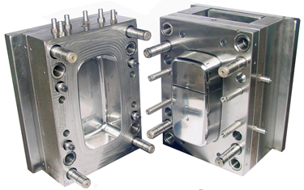 | 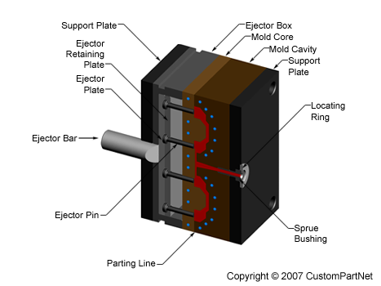
(a) | (b)
Figure 1. To format a figure caption use the Microsoft Word template style: Figure Caption. The text “FIGURE 1,” which
labels the caption, should be bold and in upper case. If figures have more than one part, each part should be labeled (a), (b), etc. Using a table, as in the above example, helps you control the layout

Points to Consider when Preparing Your Abstract
Well prepared papers enable rapid publication and reduce unnecessary work for your proceedings editor(s). The following points summarize the key issues you need to comply with when preparing your abstract.

- Check your article PDF file! It is not uncommon for errors to appear in PDFs generated from Microsoft Word – corrupted math, figures reflowing, etc. It is absolutely essential to very carefully check your article PDF file before sending it to the proceedings editor(s).
- Do not add page numbers or headers/footers. Our article templates deliberately do not include these, so please do not add them.
- Do not alter the margins of our templates. They are carefully designed for production process: Altering them can cause significant delays.
- Prepare and format references with care. Please prepare and format your references in accordance with the examples supplied with the author templates and documentation.
- Embed all fonts into your article PDF. The importance of font embedding is discussed in the section Font Embedding (above). PDFs supplied without embedded fonts are often completely unusable for printing or publication purposes. In such cases, we have to return those PDFs to the proceedings editors for font embedding. Failure to embed fonts can cause unnecessary inconvenience to your proceedings editor(s) and publication delays for other authors.
- Use clear, legible graphics and diagrams. Readers of your abstract will be grateful.
- Do not use copyrighted material without permission. Using copyrighted material without appropriate permission and acknowledgment will be excluded from the proceedings.
- Avoid large PDF files (10 MB maximum, ideally). For the benefit of your readers, we recommend keeping your article PDF file below 10 MB. This is a recommendation, not a requirement.

Acknowledgments
(Use the Microsoft Word template style: Heading 1)
The reference section will follow the “Acknowledgment” section. References should be numbered using Arabic numerals followed by a period (.) as shown below, and should follow the format in the below examples.

References
(Use the Microsoft Word template style: Heading 1)
- M. P. Brown and K. Austin, The New Physique (Publisher Name, Publisher City, 2005), pp. 25–30.
- M. P. Brown and K. Austin, Appl. Phys. Letters 85, 2503–2504 (2004).
- R. T. Wang, “Title of Chapter,” in Classic Physiques, edited by R. B. Hamil (Publisher Name, Publisher City, 1999), pp. 212–213.
- C. D. Smith and E. F. Jones, “Load-cycling in cubic press,” in Shock Compression of Condensed Matter-2001, AIP Conference Proceedings 620, edited by M. D. Furnish et al. (American Institute of Physics, Melville, NY, 2002), pp. 651–654.
- B. R. Jackson and T. Pitman, U.S. Patent No. 6,345,224 (8 July 2004)
- D. L. Davids, “Recovery effects in binary aluminum alloys,” Ph.D. thesis, Harvard University, 1998.
- R. C. Mikkelson (private communication).

